Name:P.Gayathri
Reg.No:192424324

1. Write a Python program to solve the 8-Queen Problem using Artificial Intelligence.

Aim:

To implement a Python program to solve the 8-Queen Problem by placing eight queens on a chessboard so that no two queens attack each other
Algorithm:
Step 1: Start the program.
Step 2: Create an empty 8 × 8 chessboard.
Step 3: Place the first queen in the first column.
Step 4: Check whether the current position is safe.
Step 5: If the position is safe, place the queen.
Step 6: Move to the next column and repeat the process.
Step 7: If no safe position is found, backtrack and move the previous queen.
Step 8: Continue until all eight queens are placed.
Step 9: Display the chessboard with the queen positions.
Step 10: Stop the program.

PROGRAM:

def is_safe(board, row, col, n):
for i in range(col):
if board[row][i] == 1:
return False

i = row
j = col
while i >= 0 and j >= 0:
if board[i][j] == 1:
return False
i -= 1
j -= 1
i = row
j = col
while i < n and j >= 0:
if board[i][j] == 1:
return False
i += 1
j -= 1
return True
def solve(board, col, n):
if col >= n:
return True
for i in range(n):
if is_safe(board, i, col, n):
board[i][col] = 1
if solve(board, col + 1, n):
return True
board[i][col] = 0
return False
n = int(input("Enter the number of Queens: "))

board = [[0 for i in range(n)] for j in range(n)]
if solve(board, 0, n):
print("\nSolution is:\n")
for row in board:
print(row)
else:
print("No Solution Exists")

INPUT:
Enter the number of Queens: 8
OUTPUT:
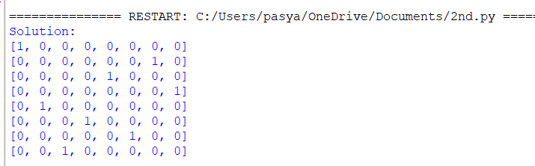

RESULT:
Thus, the Python program to solve the 8-Queen Problem using Backtracking was verified and implemented successfully.

